**SAP UI5 Activity Day 3: JavaScript**

1.) Given a number ‘number’, assuming it’s ranging from 1 – 999, convert it into

words using If.. else condition or simply if conditions or switch statement.

A dynamic code is to be generated, and a validation can be implemented to ensure that it would only

cater the number range above.

Sample input: var number = 789;

Sample output: Seven Hundred Eighty Nine

• **Code**

|  |
| --- |
| function numberToWords(n) {  const words =[  'zero', 'one', 'two', 'three', 'four', 'five', 'six', 'seven', 'eight', 'nine', 'ten',  'eleven', 'twelve', 'thirteen', 'fourteen', 'fifteen', 'sixteen', 'seventeen', 'eighteen',  'nineteen'  ];  const tens =[  '', '', 'twenty', 'thirty', 'forty', 'fifty', 'sixty', 'seventy', 'eighty', 'ninety'  ];  if(n < 20){  return words[n];  }  if(n < 100){  return tens[Math.floor(n / 10)] + (n % 10 !== 0 ? ' ' + words[n % 10] : '');  }  if(n < 1000){  return words[Math.floor(n / 100)] + ' hundred' + (n % 100 !== 0 ? ' ' + numberToWords(n % 100) : '');  }  if(n === 1000){  return 'one thousand';  }  return 'number out of range';  }  const numInput = parseInt(prompt('Enter a number from 1 to 1000:'));  if(numInput >= 1 && numInput <= 1000){  console.log(numberToWords(numInput));  } else {  console.log('Invalid Input. Please enter a number between 1 and 1000.')  } |

**• Output** (Screenshot)

Input : 654



**2.)** Using While Loop, print the pattern below. Given ‘height’ as height of the triangle and

assuming it is not a negative number.

Sample input: var height = 5;

Sample output:

* * * * *

* * * *

* * *

* *

*

• **Code**

|  |
| --- |
| let input = prompt('Enter a number:');  let i = input;  while (i > 0) {      let  rowOutput = '',           whiteSpace = '',           n = 0;      while(n < i){          rowOutput += '*';          n++;      }      n = 0;          while(n < input - i){          whiteSpace += ' ';          n ++;      }      console.log(whiteSpace + rowOutput);      rowOutput = '';      i -= 1;  } |

**• Output** (Screenshot)

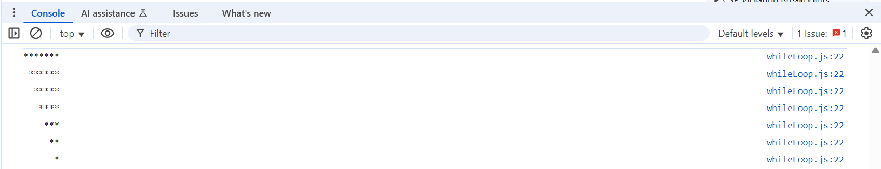

**3.)** Using For Loop, print the pattern below. Given ‘height’ as height of the ‘X’ sign and

assuming it is not a negative number and ‘height’ is an odd number.

Sample input: var height = 5;

Sample output:

* *

* *

*

* *

* *

* **Code**

|  |
| --- |
| let input = prompt('Enter an odd number:');  if(input %2 == 0){  console.log('Please enter an odd number.')  } else if (input < 0){  console.log('Please enter a positive odd number.')  } else {  for(let i = 0; i < input; i++){  let line = ' ';  for(let j = 0; j < input; j++){  if(i === j || i + j === input - 1){  line += '*';  } else {  line += ' ';  }  }  console.log(line);  }  } |

• **Output**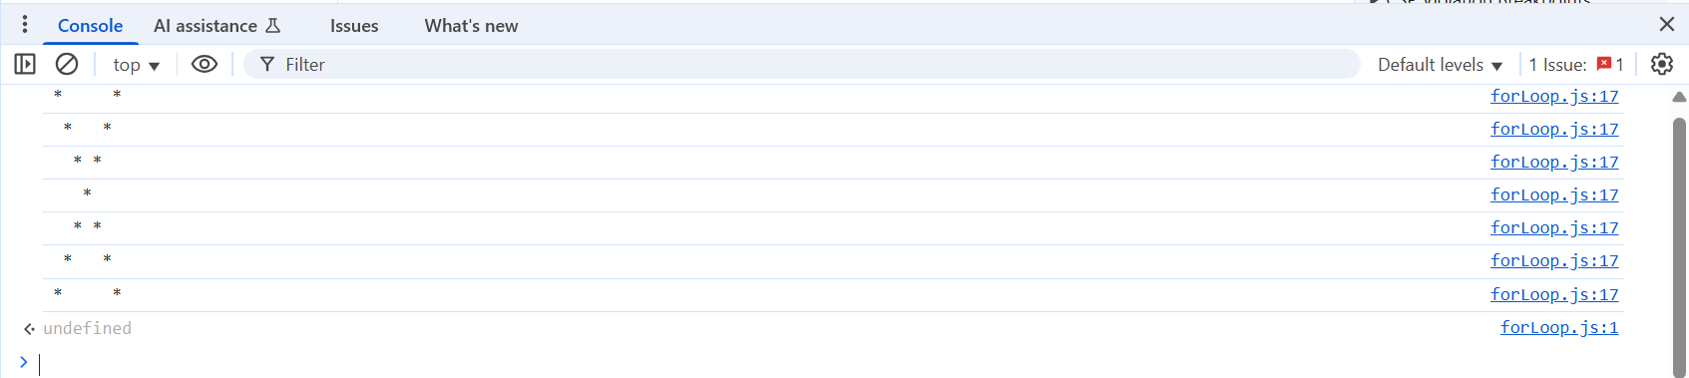

**4.)** Create a function that calculates the perimeter of a triangle. Function should return the value of

perimeter.

• Code

|  |
| --- |
| // Get side lengths from the user  const side1String = prompt("Enter the length of side 1:");  const side2String = prompt("Enter the length of side 2:");  const side3String = prompt("Enter the length of side 3:");  // Check if the inputs are valid numbers  if (isNaN(side1) || isNaN(side2) || isNaN(side3)) {  alert("Please enter valid numbers for all sides.");  } else if (side1 <= 0 || side2 <= 0 || side3 <= 0) {  alert("Side lengths must be positive numbers.");  } else {  // Calculate the perimeter  const perimeter = side1 + side2 + side3;  // Display the result  console.log("The perimeter of the triangle is: " + perimeter);  } |

• Output (Screenshot)

Input: 1, 2, 3



**5.)** We have the following arrays:

color = ["Blue ", "Green", "Red", "Orange", "Violet", "Indigo", "Yellow "];

o = ["th","st","nd","rd"]

Write a JavaScript program to display the colors in the following way (must display until the last color in

the array accordingly):

"1st choice is Blue."

"2nd choice is Green."

"3rd choice is Red."

• Code

|  |
| --- |
| let color = ['Blue', 'Green', 'Red', 'Orange', 'Violet', 'Indigo', 'Yellow'],  o = ['th', 'st', 'nd', 'rd'];  for(i = 0; i < color.length; i++){  if(i === 0){  placement = i + 1 + o[i + 1];  } else if (i === 1) {  placement = i + 1 + o[i + 1];  } else if (i === 2) {  placement = i + 1 + o[i + 1];  } else {  placement = i + 1 + o[0];  }  console.log(placement +' choice is '+ color[i]);  } |

• Output (Screenshot)

6.) Given the data below, output the data(Name and Age) of the person with

the highest number of skillset. A dynamic code should be created.

Output:Name: Patrick

Age: 22

Data:

var record = [{

"Name":"Gibo",

"Age":16,

"SkillSet" : [{

"Skill":"SAP UI5"

},{

"Skill":"SAP HANA"

}]

}, {

"Name":"Patrick",

"Age":22,

"SkillSet" : [{

"Skill":"SAP UI5"

}, {

"Skill":"SAP HANA"

}, {

"Skill":"SAP ABAP"

}]

}, {

"Name":"MJ",

"Age":24,

"SkillSet" : [{

"Skill":"SAP HANA"

}]

}];

• Code

|  |
| --- |
| var records = [{      name:  'Gibo',      age: 16,      skill: [          'SAP UI5',          'SAP HANA'      ]  },{      name: 'Patrick',      age: 22,      skill: [          'SAP UI5',          'SAP HANA',          'SAP ABAP'      ]  },{      name: 'MJ',      age: 24,      skill: ['SAP HANA']  }];      maxSkillsCount = 0;  records.forEach(record => {      if(record.skill.length > maxSkillsCount){          maxSkillsCount = record.skill.length;          recordMostSkilled = record;      }  });  console.log('Name: ' + recordMostSkilled.name);  console.log('Age: ' + recordMostSkilled.age); |

• Output (Screenshot

